**Figure 1**. Distribution of *Quercus pyrenaica* forests in Iberian Peninsula (a) and in Sierra Nevada mountain (b). Different colours indicate oak population cluster’s identified in Sierra Nevada (Pérez-Luque et al. 2015). For each population, a grid with the MODIS pixels is shown (see material and methods). Detailed location of the dendroecological sampling sites: northern (San Juan, SJ) (c) and southern ones (Cáñar: CA-Low and CA-High) (d). Colour Orthophotography of 2009 from Regional Ministry of the Environment, Regional Government of Andalusia.

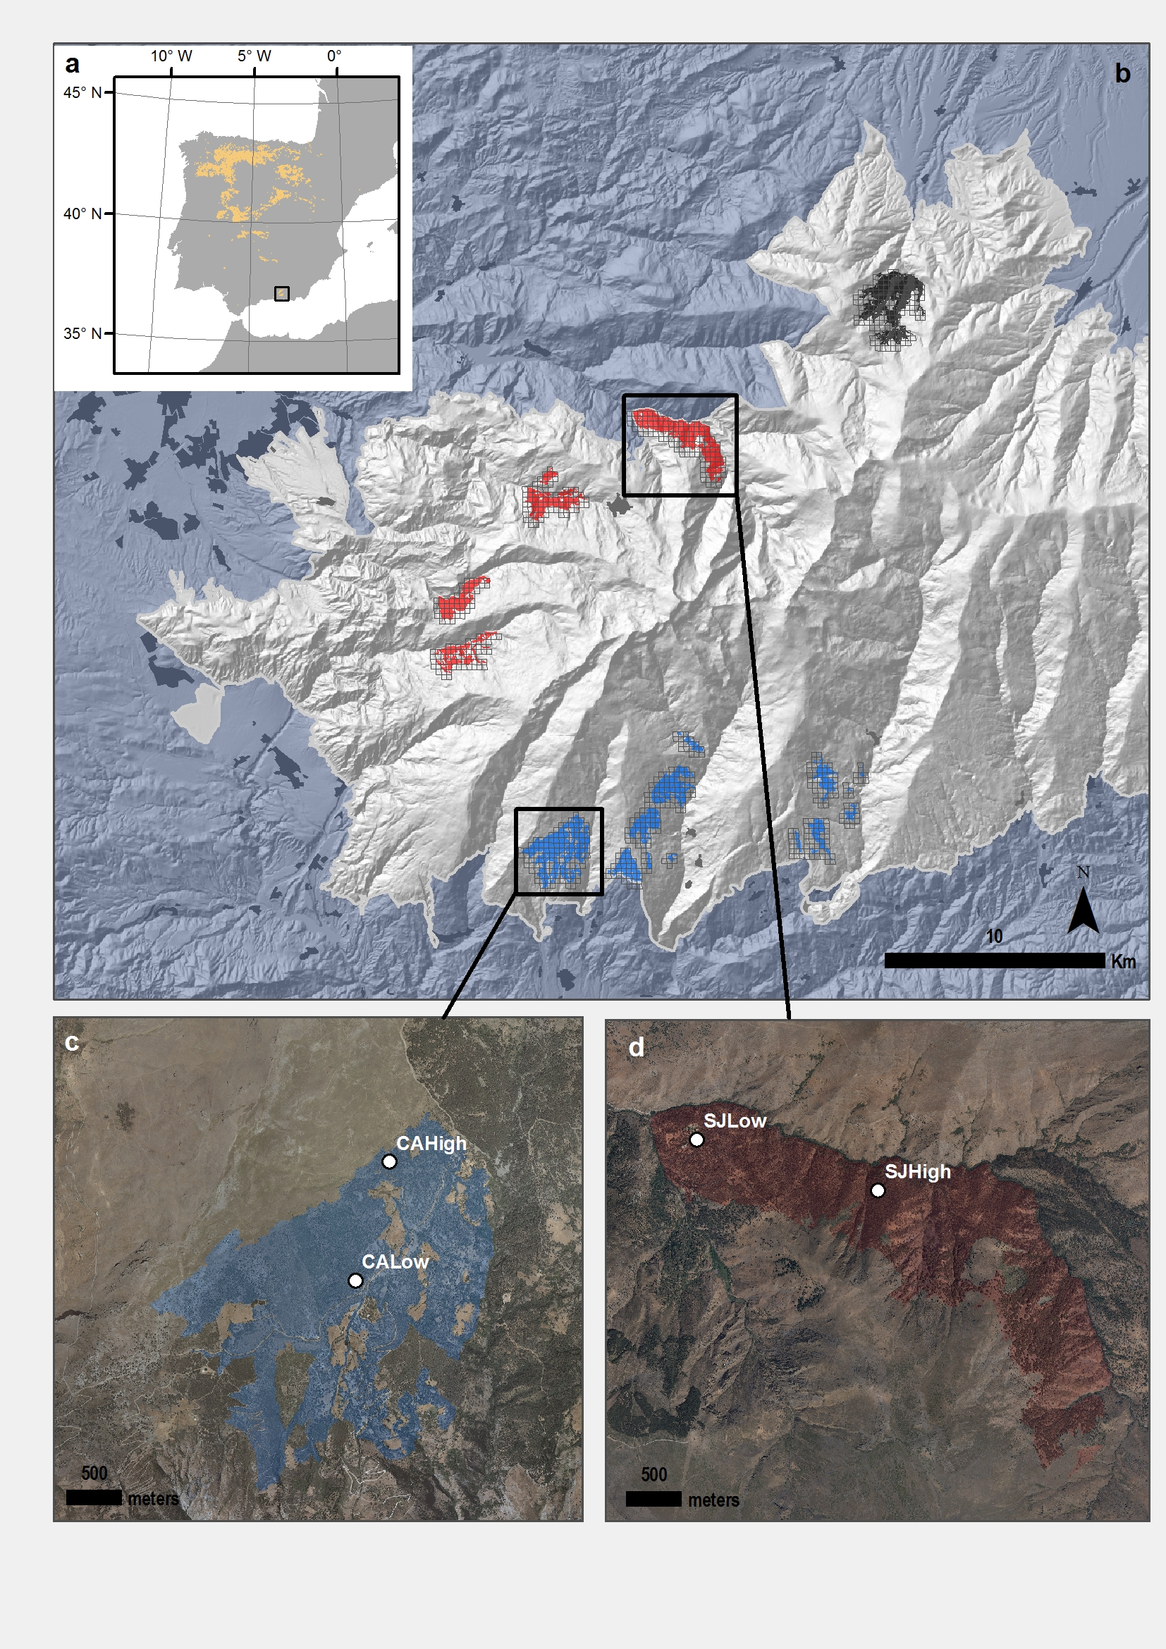

##### 

**Figure 2.** EVI standardized anomaly during the period 2000-2016 for northern and southern populations. Error bars show standard error.

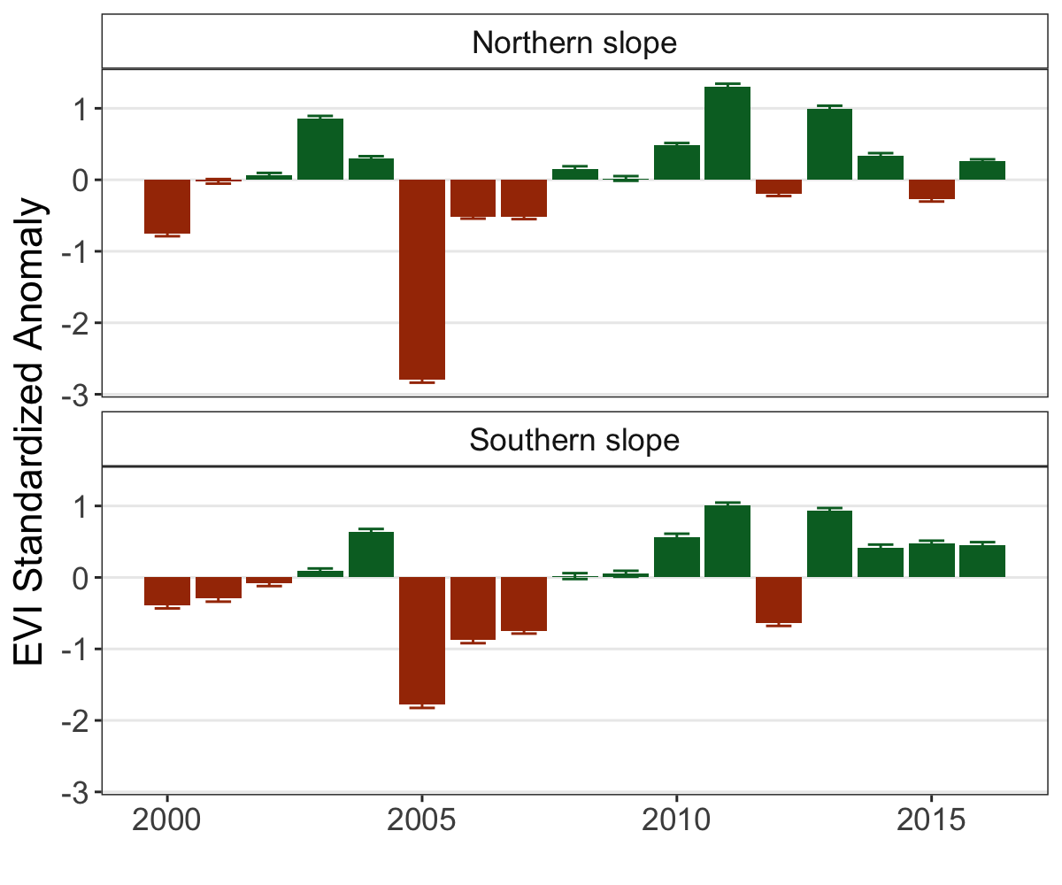

##### 

**Figure 3.** Response *Q. pyrenaica* forests to drought in terms of resistance, recovery and resilience of greenness (EVI; left-plots) and tree radial growth (BAI; right-plots) for the years 2005 and 2012. For EVI we compared northern populations (*black fill circle*) with southern ones (*blue empty circle*). For BAI we compared northern population (San Juan, SJ; *black triangle*) with southerns populations: Cáñar-High (CA-High; *blue empty squares*) and Cáñar-Low (CA-Low; *blue fill squares*). Different letters above error bars indicate significant *post hoc* differences between groups (see material and methods).

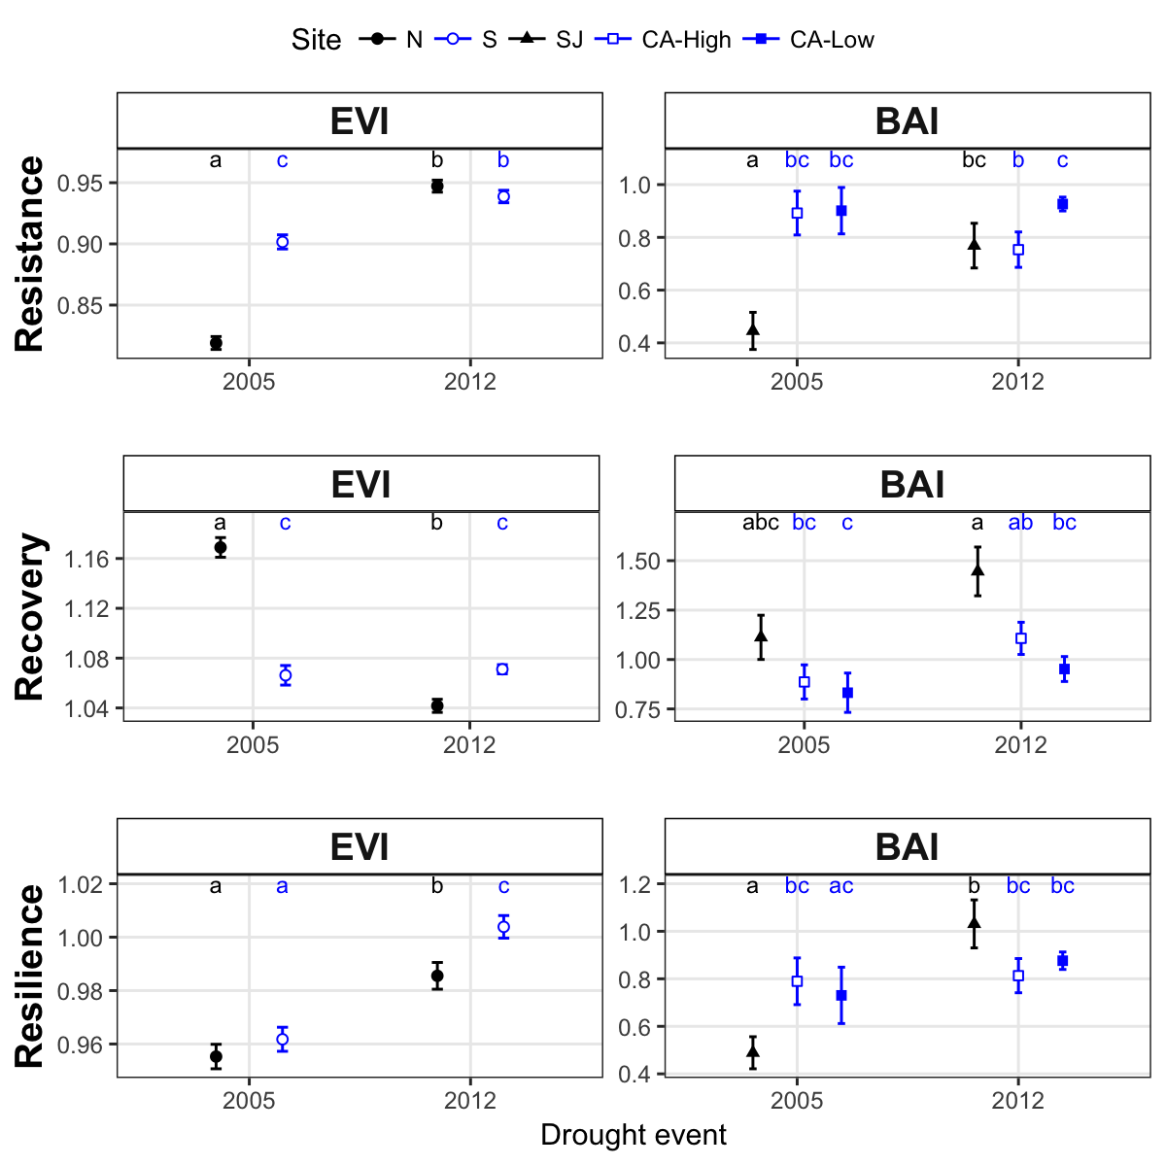

##### 

**Figure 4.** Basal Area Increment (BAI) chronologies of *Q. pyrenaica* for northern population (SJ; *green*) and southern ones: low-elevation (CA-Low; *pink*) and high-elevation (CA-High, *purple*) sites. Shading areas coorespond to standard error of the mean. Number of series are displayed in the upper plot. We only show chronologies with # trees > 5. Linear trend since 1975 is shown for southern high-elevation site (CA-High) ( $r_{2}$ = r2).

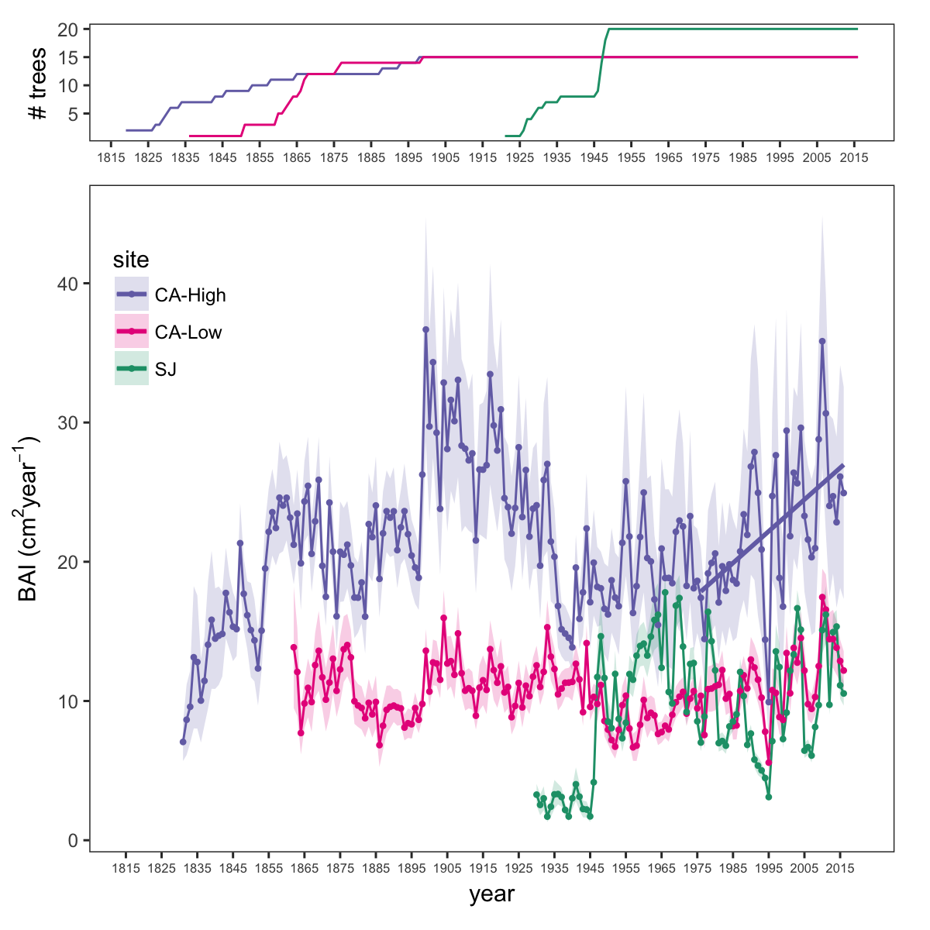

##### 

**Figure 5.** Residual Tree-ring chronologies obtained for the *Q. pyrenaica* sites. Dashed red lines indicate the start of the reliable period (EPS > 0.85). Dotted black lines showing the three of most recent severe drought years (1995, 2005 and 2012).

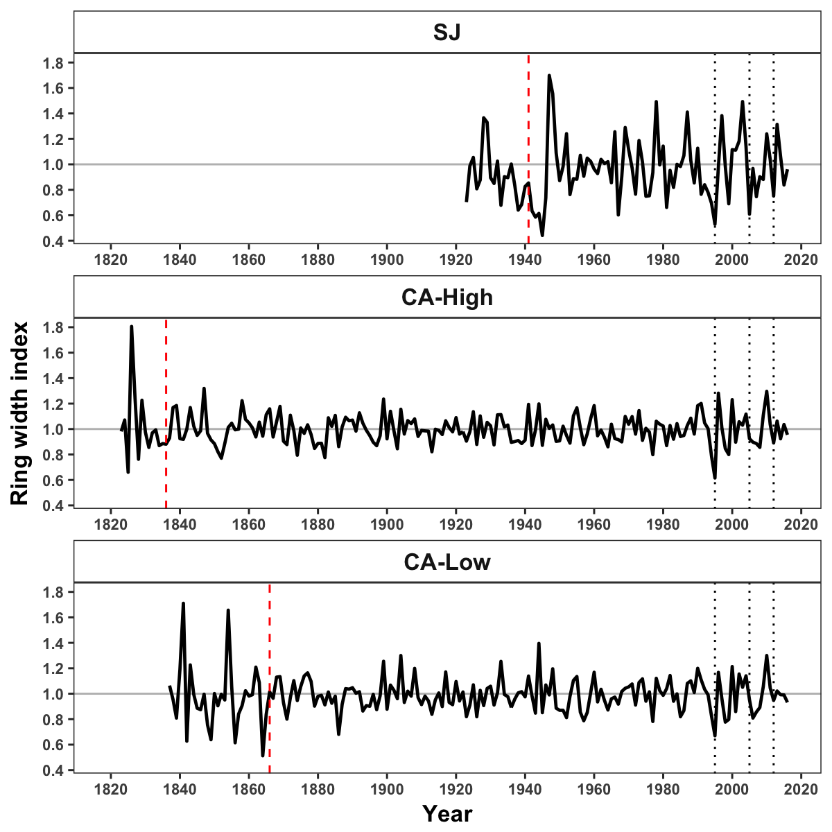

##### 

**Figure 6.** Correlation coefficients obtained by relating tree-ring residual chronologies (RWI) of *Q. pyrenaica* and monthly climatic data: precipitation (a), SPEI (b), maximun (c) and minimun (d) temperatures. *green* bars: northern site (SJ); *light blue* bars: low-elevation southern site; and *dark blue* bars: high-elevation shouthern site. Asteriks indicate significant ($P<0.05$) correlation coefficients.

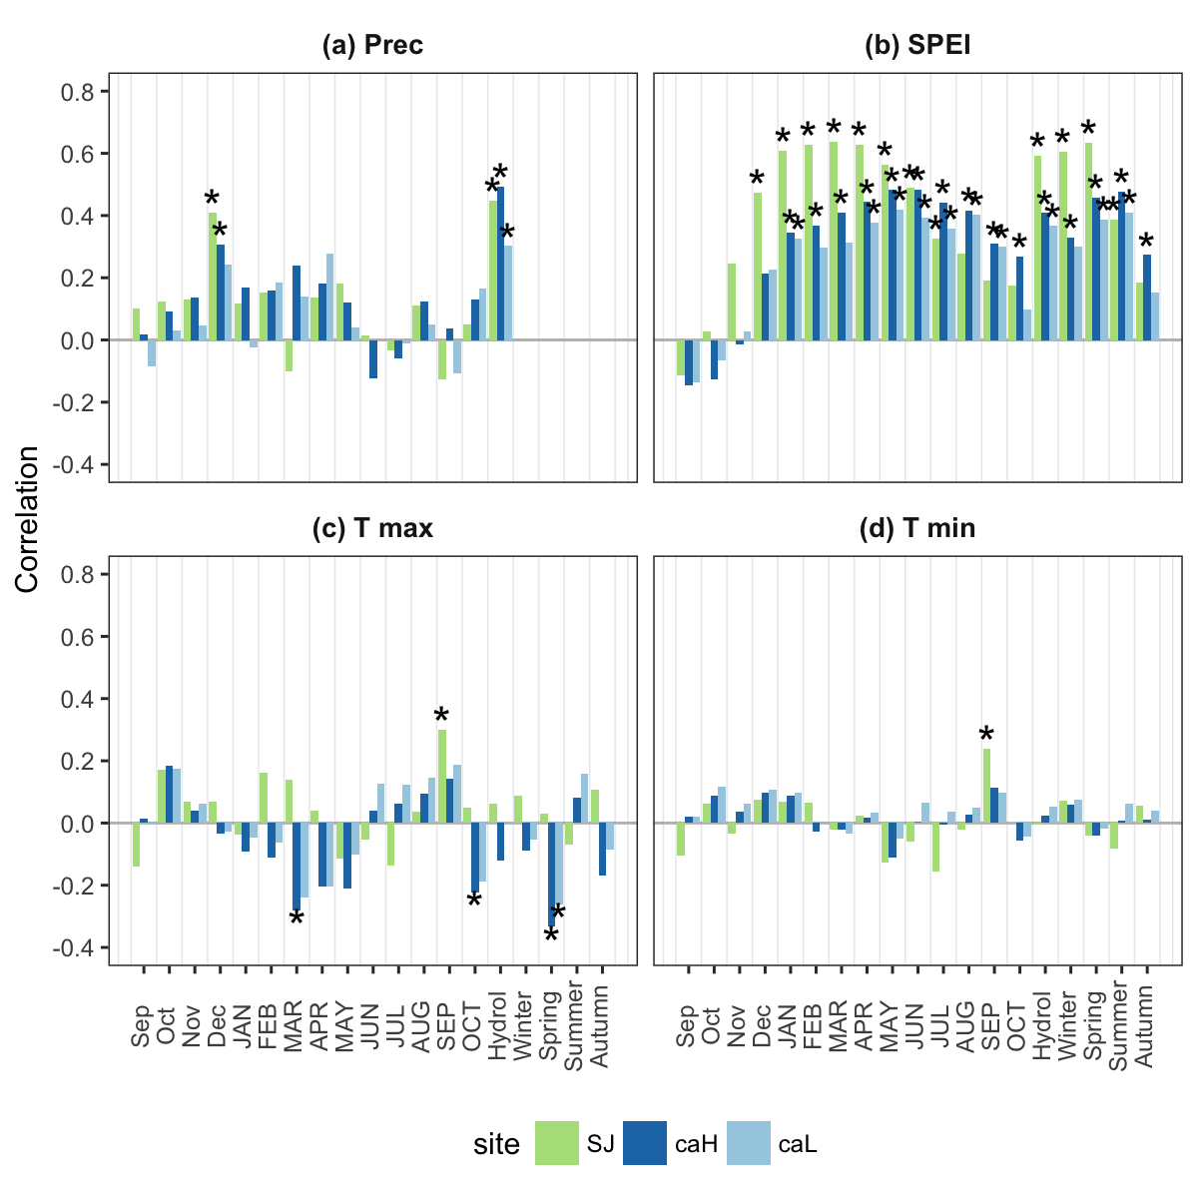

##### 

**Figure 7.** Comparison of median growth change ($GC$) following Nowacki and Abrams (1997) for *Q. pyrenaica* sites. Dashed black lines indicate a threshold of 50 % of GC (see material and methods).

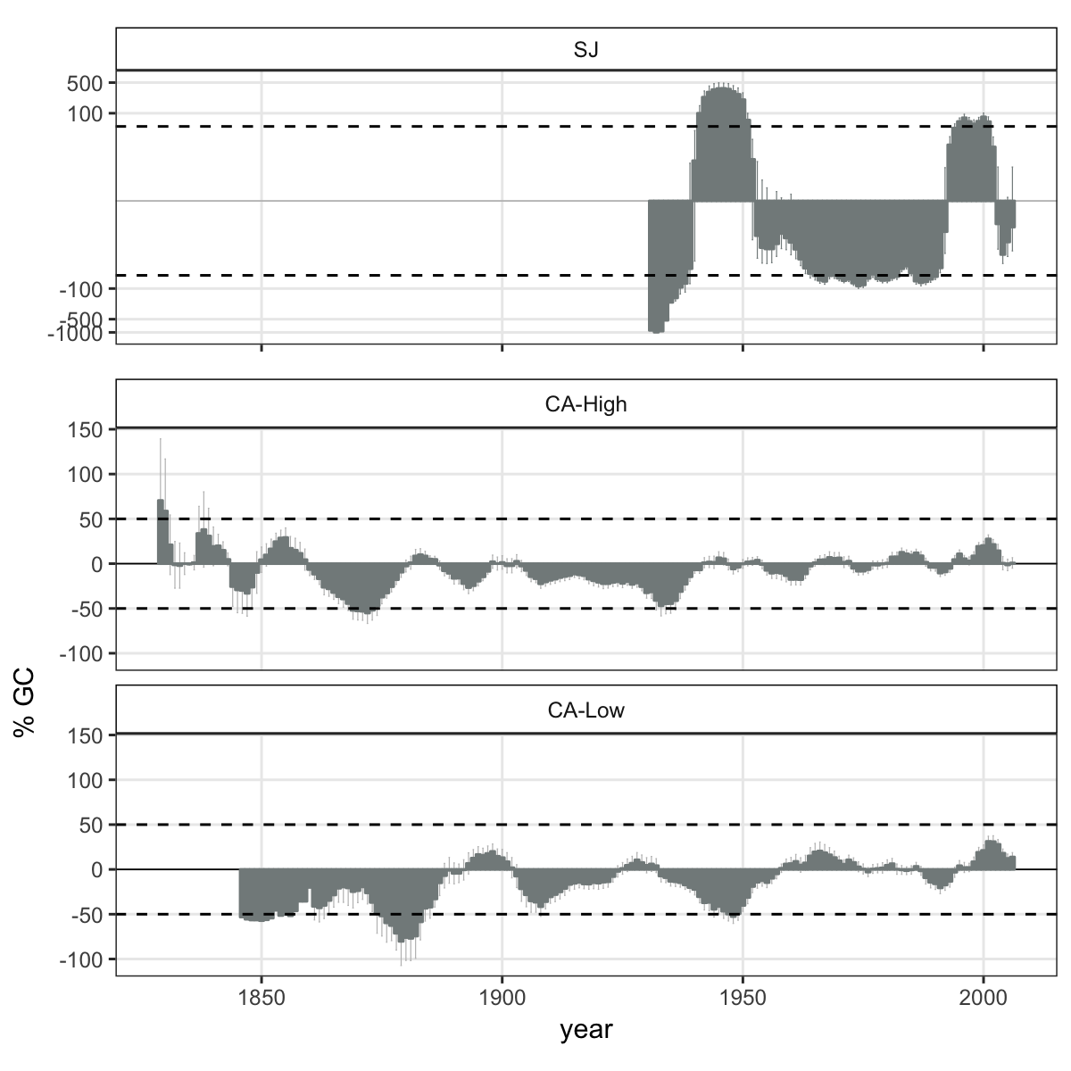

##### 

**Figure 8**. Percentage of *Q. pyrenaica* trees affected by GC > 50 % by site. *Black* line shows number of trees (rigth-axis).

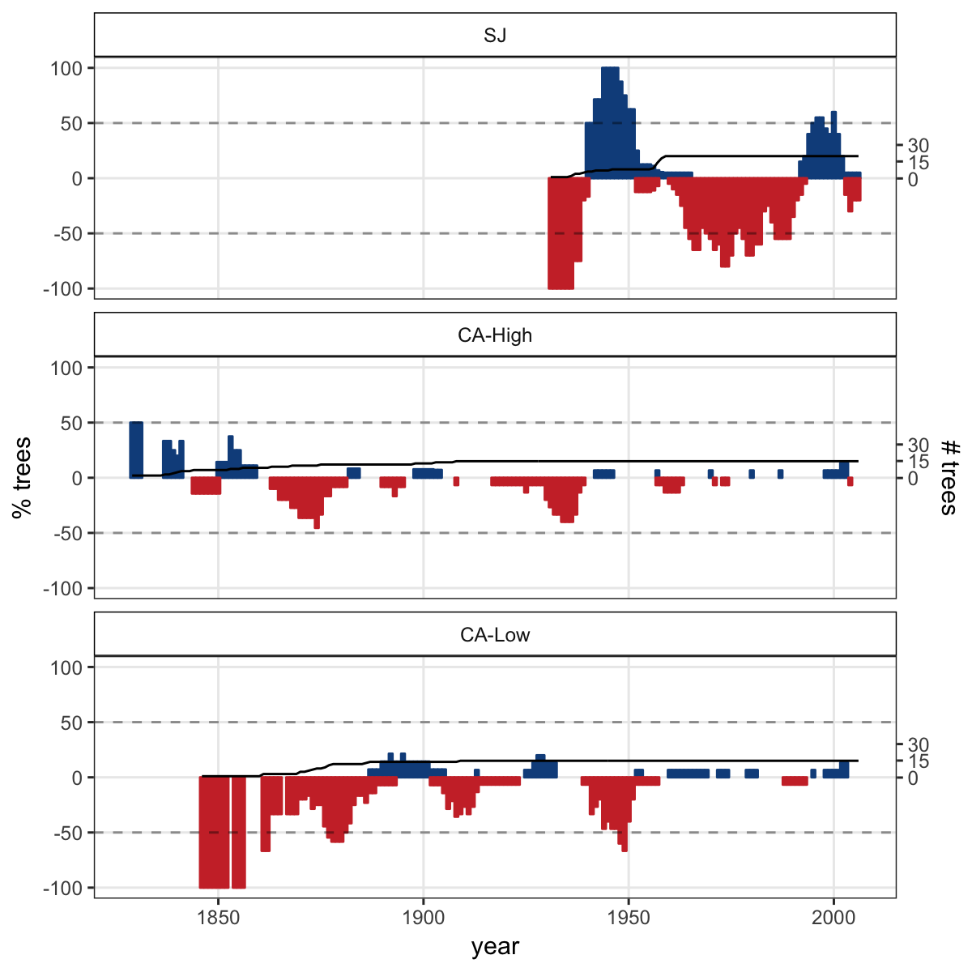 ##### **Appendix S1.** Temporal evolution of cumulative precipitation (hydrological year) during the period 1950-2017. Points represent mean and errorbars standard error. *Black* line indicates mean for all period. *Red* lines represent -1 and -2 standard deviation (*dotted* and *dashed* lines respectively). *Blue* lines represent +1 and +2 standard deviation (*dotted* and *dashed* lines respectively). Years with average values below -1SD are labelled. Data from 28 meteorological stations distributed around Sierra Nevada area (from National Spanish Meteorological Services, AEMET). ***Inset plot***: cumulative precipitation during the hydrological years 2004-2005 (*blue line*) and 2011-2012 (*red line*). The boxplot representing the average from 1950-2015 period. Data from meteorological station Granada, Base Aérea.

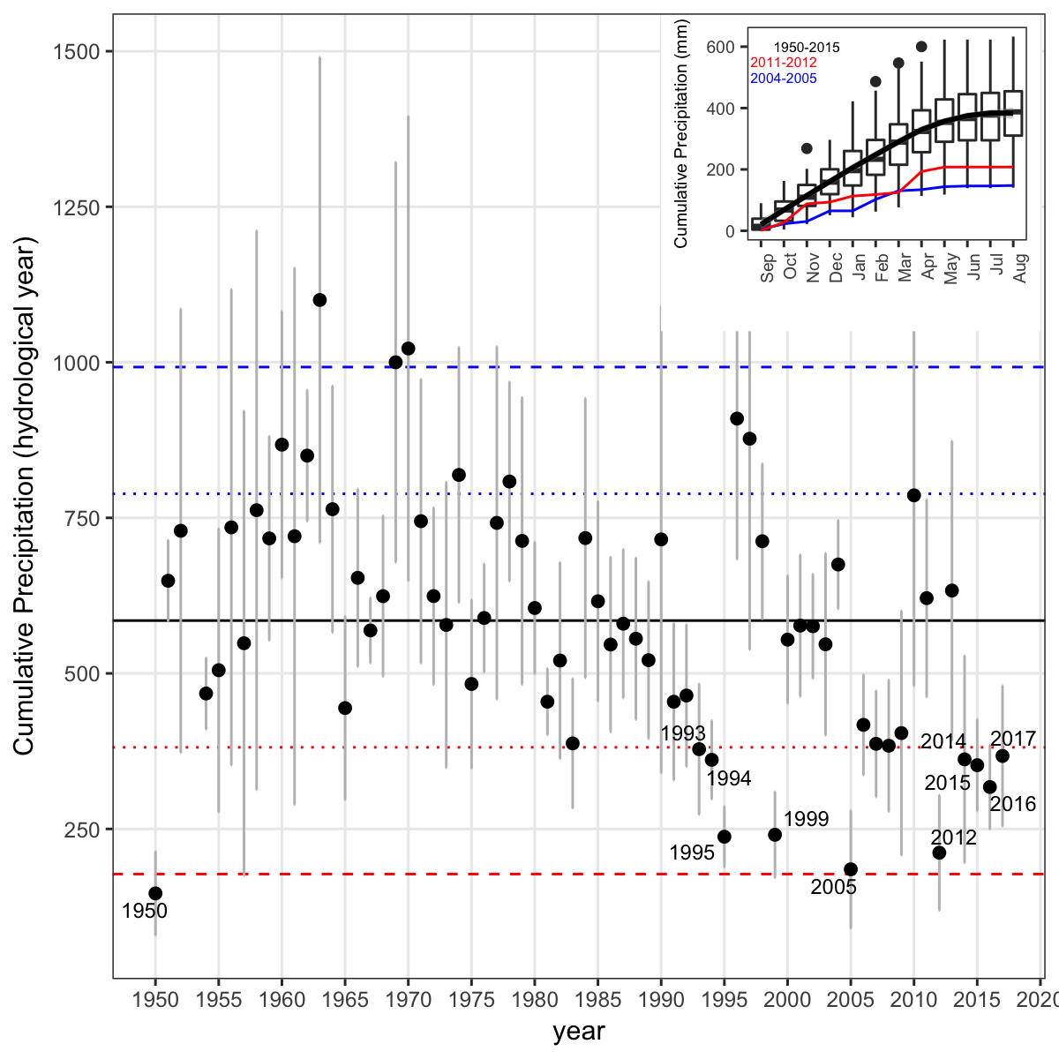

##### 

**Appendix S2**. Drought severity in the Sierra Nevada for the 1950-2016 period based on the Standardised Precipitation-Evapotranspiration Index (SPEI). Data from Global SPEI database (<http://spei.csic.es/database.html>). We obtanied the SPEI data for a 12 month scale and for all 0.5º grid cells covering Sierra Nevada.

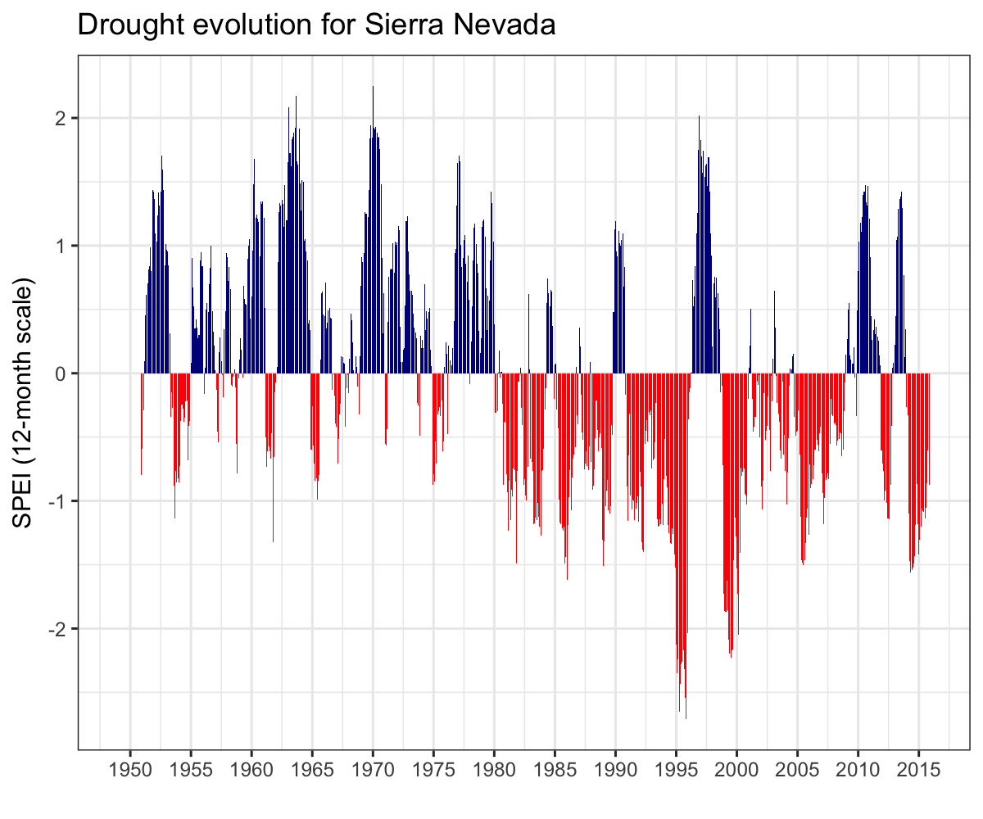

##### 

**Appendix S3.** Drought events for Sierra Nevada based on SPEI index. A drought event starts in the month when SPEI falls below the threshold of -1.28 (Páscoa et al. 2017). A drought event is considered only when SPEI value are below threshold for at least two consecutive months (*e.g* Spinoni et al. 2015, Spinoni2017a; Páscoa et al. 2017). The ***duration*** of a drought event is the number of consecutive months with the SPEI lower than a certain threshold. ***Severity*** of a drought event is the sum of the SPEI values (absolute values) during the duration of the drought event. ***Intensity*** and \***Lowest SPEI** refer to the mean and lowest value of SPEI respectively during the drought event duration.

|  |  |  |  |  |
| --- | --- | --- | --- | --- |
| Duration (months) | Intensity | Severity | Lowest SPEI | Year |
| 11 | -1.581 | 17.39 | -2.024 | 1913-1914 |
| 11 | -1.957 | 21.52 | -2.585 | 1995 |
| 9 | -1.823 | 16.41 | -2.427 | 1945-1946 |
| 9 | -1.764 | 15.88 | -2.056 | 1998-1999 |
| 8 | -1.482 | 11.86 | -1.654 | 1983 |
| 6 | -1.728 | 10.37 | -1.906 | 2012 |
| 5 | -1.905 | 9.527 | -2.3 | 1925 |
| 5 | -1.493 | 7.463 | -1.537 | 1985 |
| 5 | -1.385 | 6.926 | -1.444 | 1991 |
| 5 | -1.522 | 7.611 | -1.571 | 2005 |
| 4 | -1.363 | 5.453 | -1.441 | 1927 |
| 4 | -1.714 | 6.855 | -1.833 | 1931 |

##### 

**Appendix S4.** Percentage of pixels showing browning, greenning or no-changes during the 2005 and 2012 droguht events according to EVI standardized anomalies.

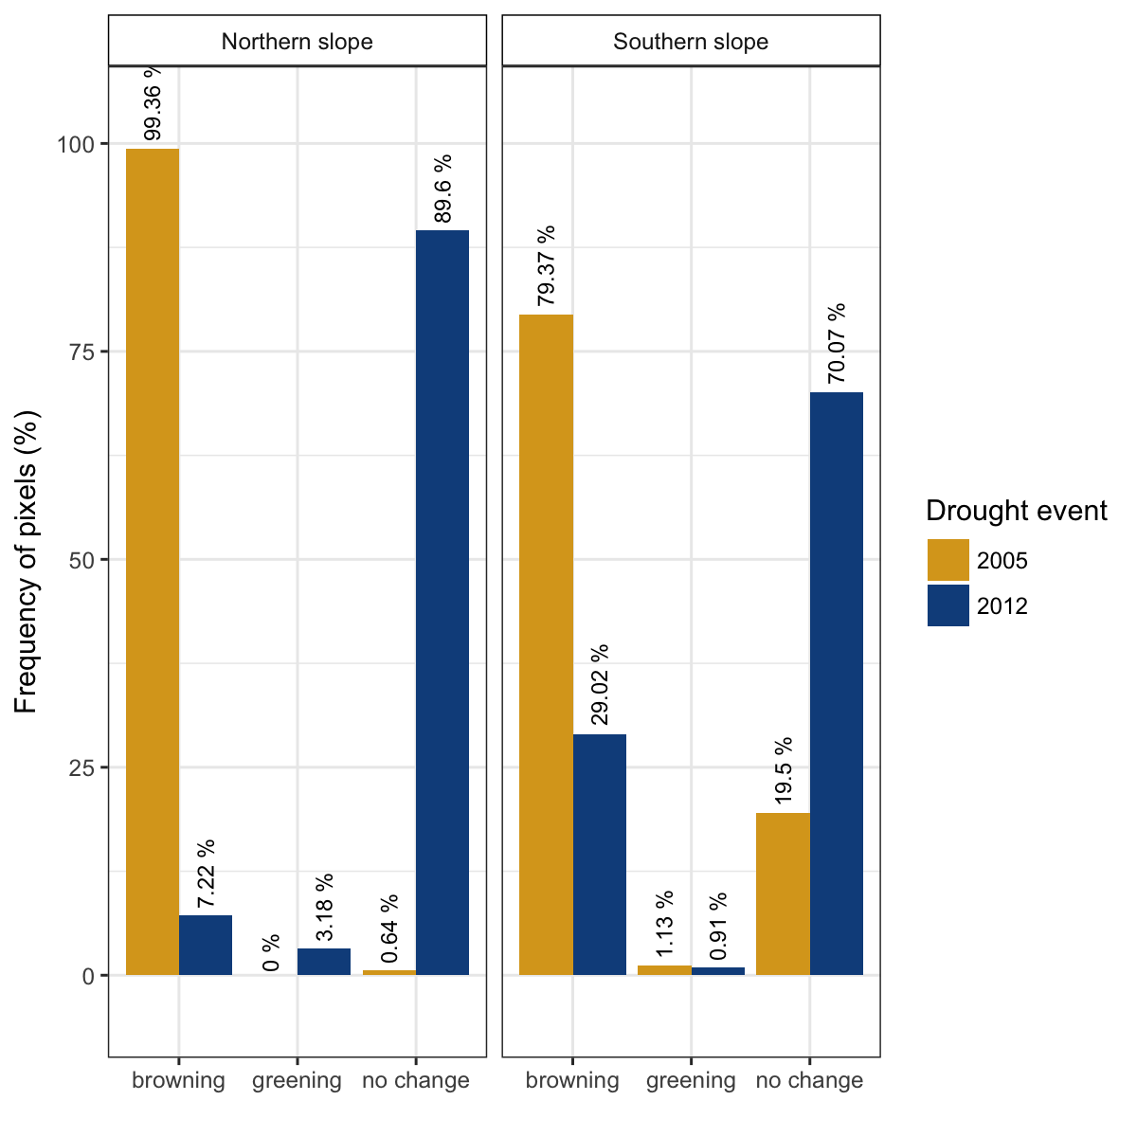

##### 

**Appendix S5.** Resilience metrics of the tree-growth for the most severe drought events. *Left*: Resistance (*Rt*); *Center*: Recovery (*Rc*); *Right* Resilience (*Rs*). Points indicate average of resilience metrics for all populations. Error bar corresponds standard error. Resilience metrics were computed for each population (sample depth > 10) and drought event.

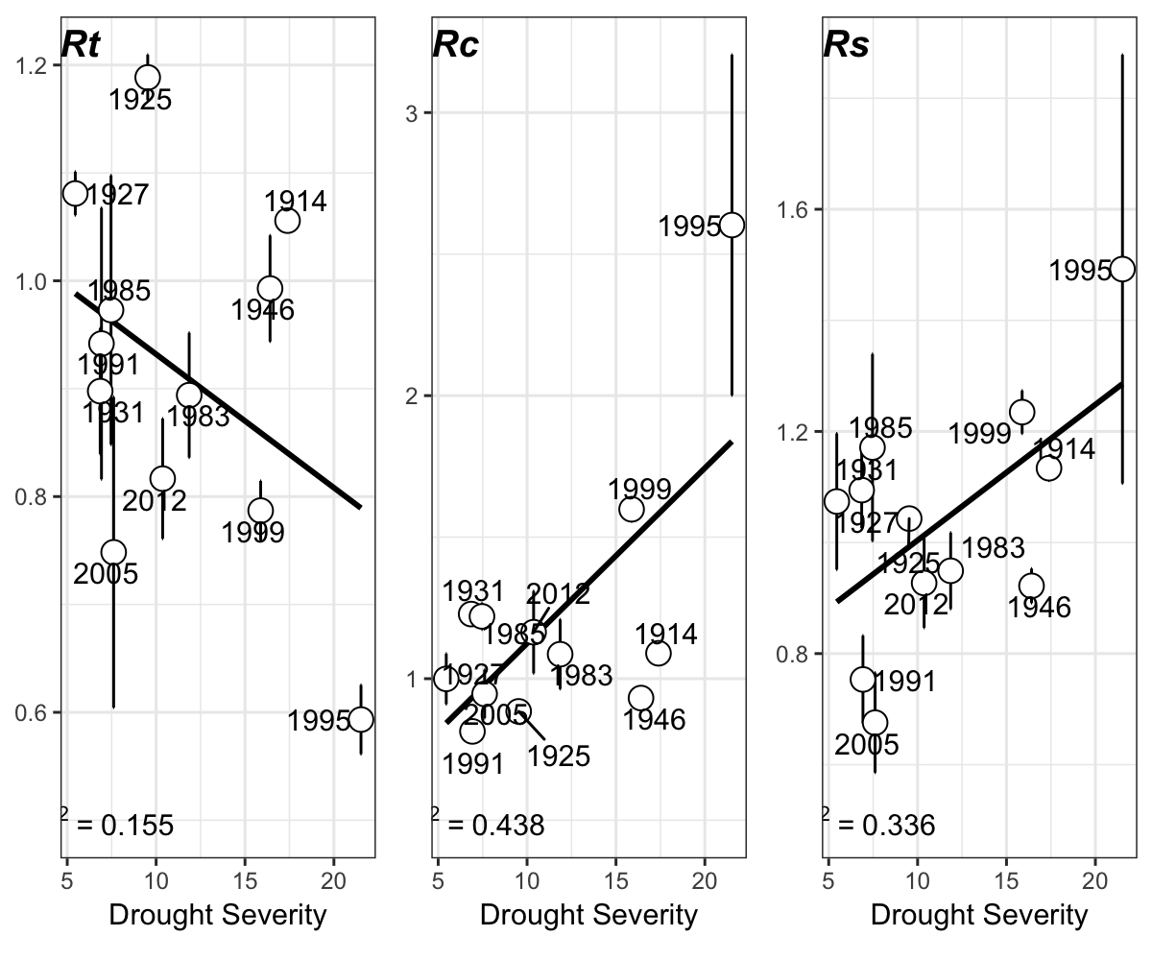

##### 

**Appendix S6.** Correlation between indices of resilience (*Rt*, resistance; *Rc*, recovery; *Rs*, Resilience) using periods of several lengths (2, 3 and 4 years after a drought). Top plots (a, b and c) showing the resilience indices of greenness (EVI) to drought; and bottom plots (d, e, f) the resilience indices of tree-growth (BAI) to drought.

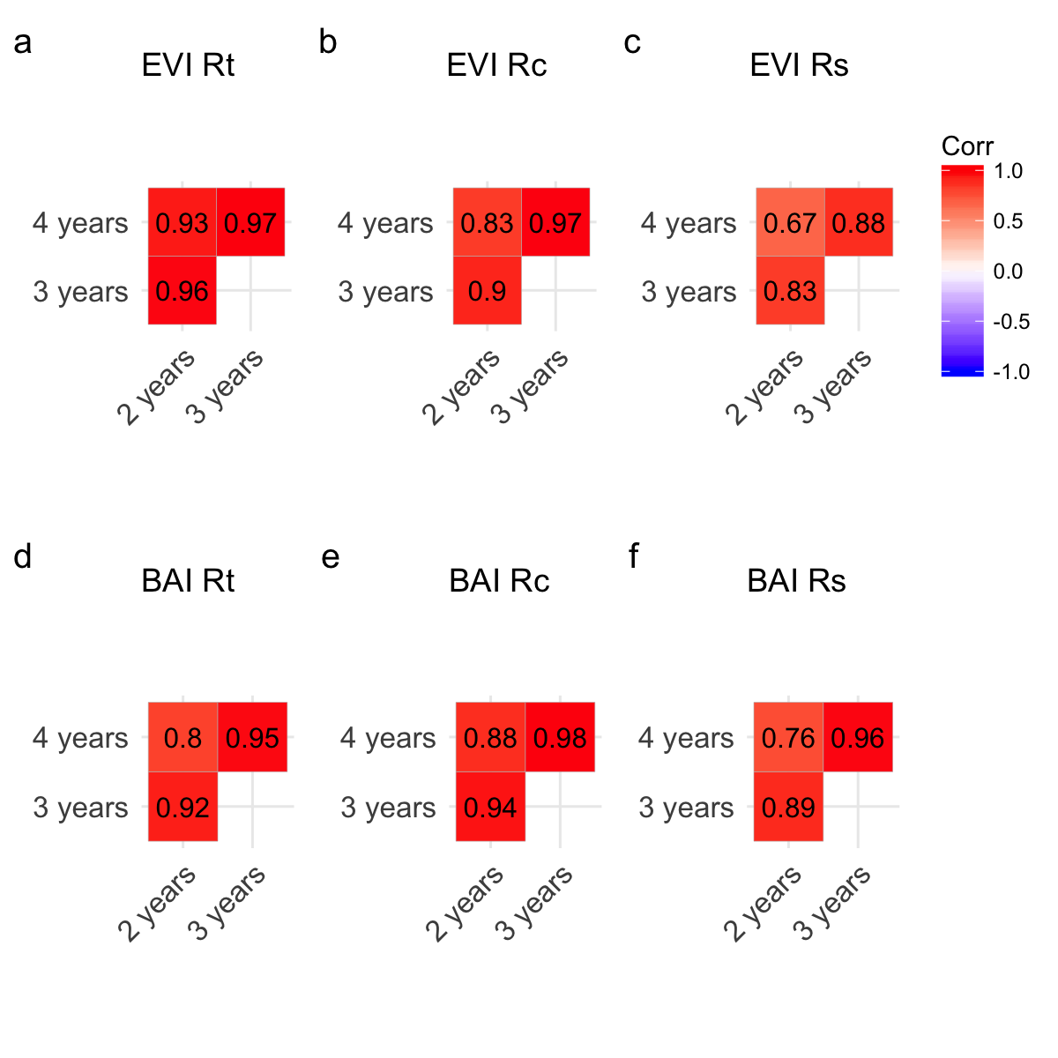

##### 

**Appendix S7.** Growth commparations

##### 

**Appendix S8.** Tabla S1

##### 

**Appendix S9.** Tabla S2

##### 

**Appendix S10.** Comparison EVI previous and post

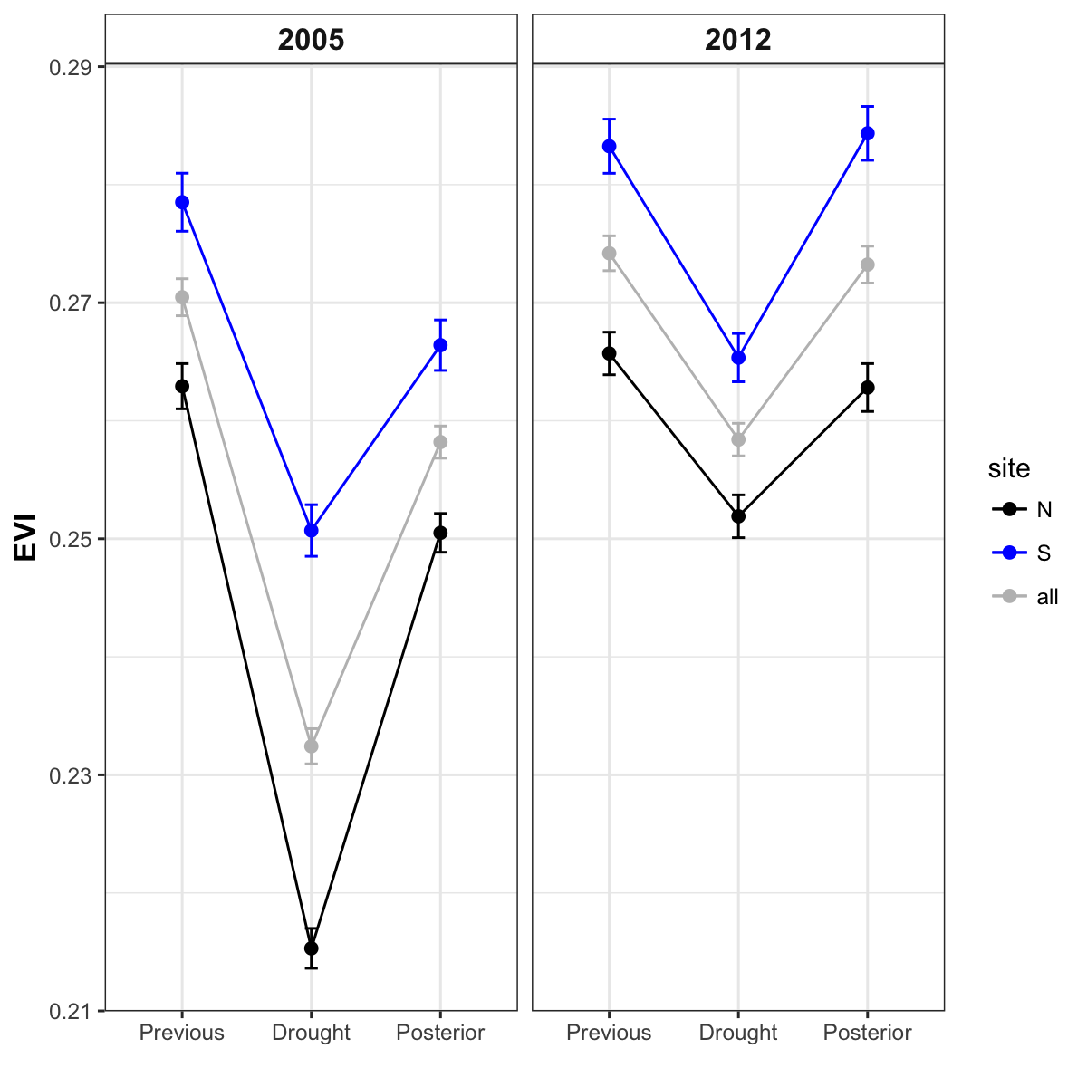

Nowacki, G. J., and M. D. Abrams. 1997. Radial-growth averaging criteria for reconstructing disturbance histories from presettlement-origing oaks. Ecological Monographs 67:225–249.

Páscoa, P., C. Gouveia, A. Russo, and R. Trigo. 2017. Drought trends in the iberian peninsula over the last 112 years. Advances in Meteorology:ID4653126.

Pérez-Luque, A. J., R. Zamora, F. J. Bonet, and R. Pérez-Pérez. 2015. Dataset of migrame project (global change, altitudinal range shift and colonization of degraded habitats in mediterranean mountains). PhytoKeys 56:61–81.

Spinoni, J., G. Naumann, J. V. Vogt, and P. Barbosa. 2015. The biggest drought events in europe from 1950 to 2012. Journal of Hydrology: Regional Studies 3:509–524.